News release

May 6, 2013
For more information:
Mary Waggoner, Director of Communications, 425-385-4040
Kate Reardon, Public Information Director, city of Everett, 425-257-8687

More than 300 screened at Cascade High School in the Nick of Time
Seattle-based organization dedicated to spotting youth cardiac health issues

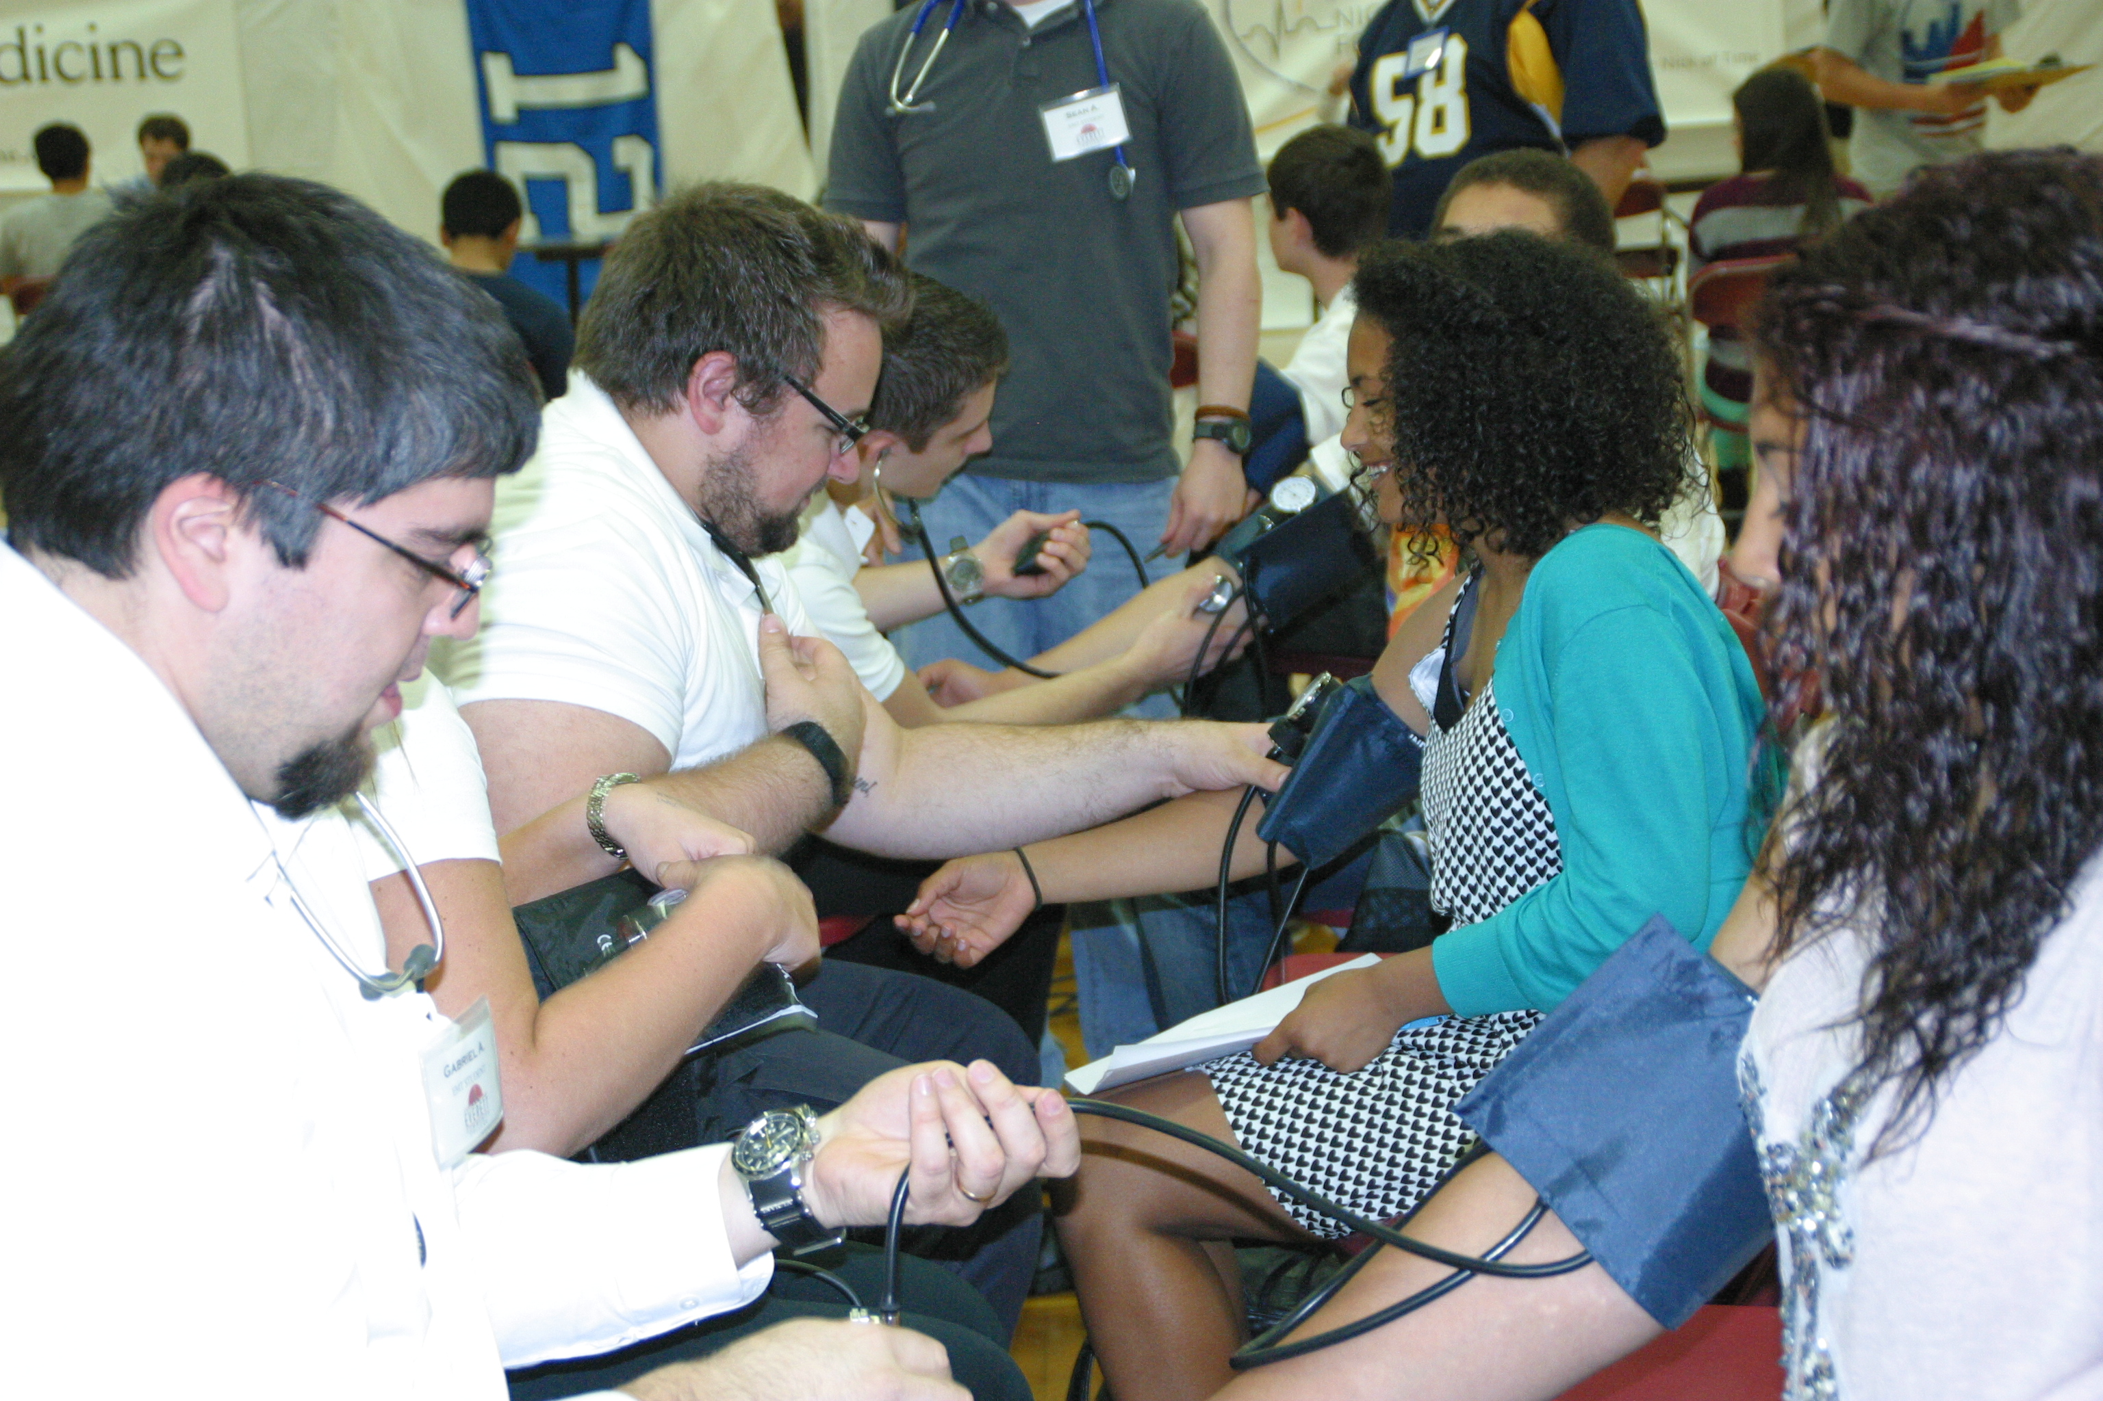
With the help of Everett Fire Department’s paramedic volunteers, the Nick of Time Foundation and its 100 volunteers and corporate sponsors converged on the gymnasium at Cascade High School April 30 for a day of screening students for indicators of cardiac health issues. “Altogether 301 young hearts were screened,” reported Robert Polk, Everett Public Schools athletic director. “We found two who needed immediate follow-up, and 10 who will need to be monitored for a family history or for elevated blood pressure.”

Polk noted the teamwork involved in making the day a successful streamlined process. “The school administration and sports medicine class were amazing and provided lots of support to our team. A special shout out to Dave Peters, Cascade High athletic director
Paramedic students check blood pressure at one of the Nick of Time cardiac health stations during the April 30 event at Cascade High School.
and Kristen Harvey, the school’s sports medicine teacher – and to the restaurants and businesses who donated food and snacks to feed the hundreds of students and volunteers.”

Photos for the day and more information about upcoming Nick of Time screenings are on the Nick of Time Facebook page.

See earlier story online.

---end---

